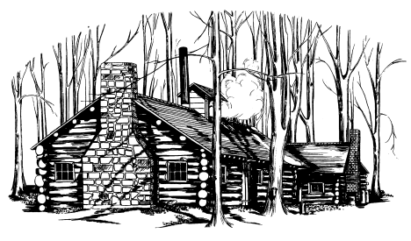

Save the Burton Chamber Log Cabin and
It’s Maple Legacy

Donor Contribution Form

Make checks payable to:
Burton Cabin Foundation and mail to:
Burton Chamber of Commerce
POB 537, Burton, OH 44021
Or donate online at:
www.burtonchamberofcommerce.org

Please print clearly:
Donor Name or Corporation: ____________________________________________________

Contact Name: _______________________________________________________________

Mailing Address _____________________________________________________________

Phone ( ) ________________________ Email _________________________________

Donation Amount: $___________________________________________________________

In memory of or in name of: ____________________________________________________

Credit Card Information: ________Visa ________Master Card

Card #: _____________________ Expiration Date: __________ Security Code: _________

Donor Signature: ______________________________________ Date: ________________

